Website programming report – Kasim
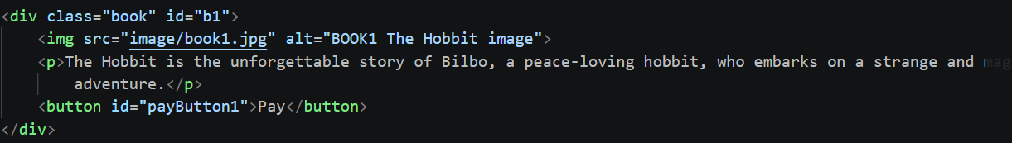
This first example shows an alternate way of presenting the book if the user has images blocked or doesn’t load, the user can clearly see the name of the book. This helps with accessibility because it helps the user understand what the content includes.

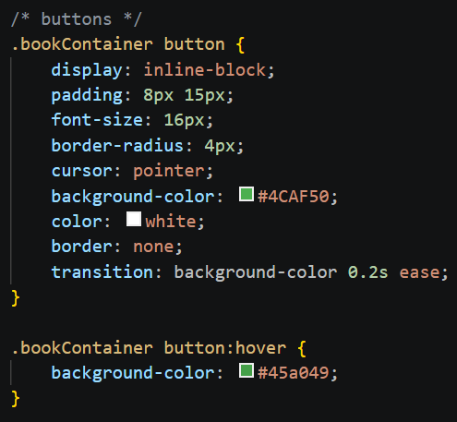
This example in my CSS shows that the colour of the pay button is green, distinct from the white background, this ensures that users are clearly able to see the button to pay, especially with the contrasting white text.

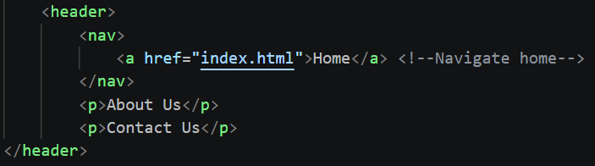
This example helps the user navigate back to the home page if they want to switch the book when they are on the payment page, this ensures that the user doesn’t have to re-enter the website URL or use browser navigation just to go back to the previous page.

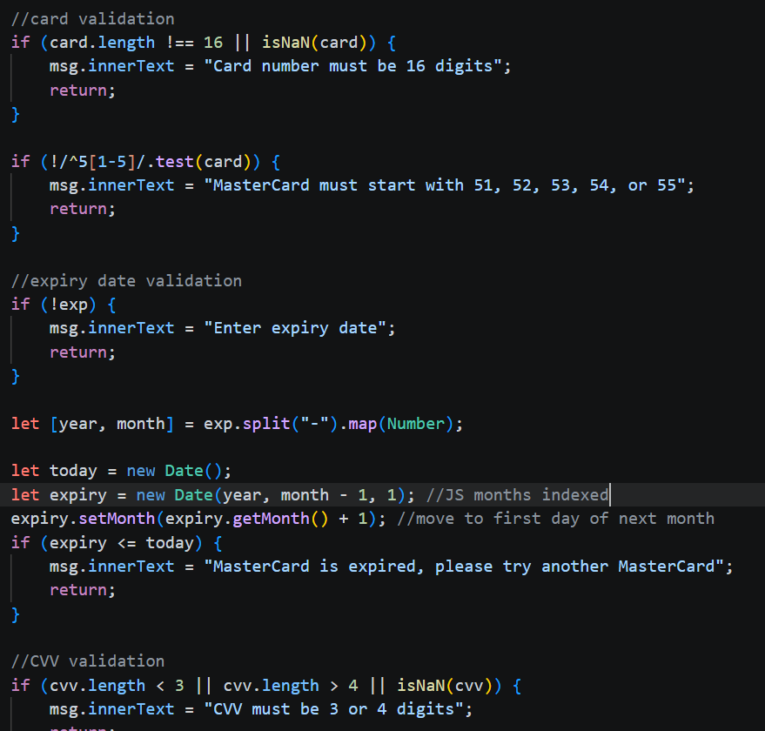
This code ensures that the payment card data is as expected through validation, it ensures that mistakes or erroneous or incorrect information is not passed through to the mudfoot server, ensuring that the data is as expected.

Lastly, code was used from CSS to ensure that the webpage I usable for smaller screens such as mobile phones, on the home page, book covers are changed into uniform one per column to ensure users are able to see the book cover and description easily without being overwhelmed with two books side by side on a small screen.

